SAMPLE MOTIONS IN REMOVAL PROCEEDINGS

Sometimes, an immigrant cannot find or cannot afford an attorney to represent them in removal proceedings. These materials will help those aliens without attorneys buy more time to look for a lawyer and apply for benefits. As a disclaimer, these samples apply generally. A lawyer SHOULD review the final version of these documents before filing with the immigration court. Please read your motion carefully! Below is a sample Written Plea and Motion to Change Venue with a courtesy Judge’s decision template and a necessary Certificate of Service. Evidence of changing your address (like a new lease or mortgage in a new city) is absolutely necessary to include! This motion is generally for people who have not appeared in immigration court yet but have a court date approaching. After filing with the court, make sure to send the appropriate ICE office a copy. Use wisely!
I am including this sample motion because the location of your court and the identity of your Immigration Judge is CRUCIAL to the outcome of your case. This is especially true if you are eventually going to apply for asylum. Please see this study by Syracuse University in New York that shows the varying rates of asylum grants from city to city and judge to judge. If you change your address (and sometimes you should) – CHANGE YOUR VENUE!

Johnny Smith
Pro Se
123 Main Street
Anywhere, NY 01987
P: (555) 554-1212
E: johnnysmith@whatmail.com

UNITED STATES DEPARTMENT OF JUSTICE
EXECUTIVE OFFICE FOR IMMIGRATION REVIEW
SAN ANTONIO IMMIGRATION COURT
____________________________________
In the Matter of: )
)
Smith, Johnny ) File No. 123456789
)
In Removal Proceedings )
____________________________________)

Immigration Judge: Johnson Master hearing date: December 30, 2027 at 1PM

RESPONDENT’S WRITTEN PLEA
RESPONDENT’S MOTION TO CHANGE VENUE
Johnny Smith
Pro Se
123 Main Street
Anywhere, NY 01987
P: (555) 554-1212
E: johnnysmith@whatmail.com

UNITED STATES DEPARTMENT OF JUSTICE
EXECUTIVE OFFICE FOR IMMIGRATION REVIEW
SAN ANTONIO IMMIGRATION COURT
____________________________________
In the Matter of: )
)
Smith, Johnny ) File No. 123456789
)
In Removal Proceedings )
____________________________________)

Immigration Judge: Johnson Master hearing date: December 30, 2027 at 1PM

RESPONDENT’S WRITTEN PLEA

RESPONDENT’S MOTION TO CHANGE VENUE

TABLE OF CONTENTS

Tab Pages
A. E-33 Change of Address………………………………………………………………….…..1
B. Respondent’s Written Plea………………………………………………………………….2-4

B. Motion to Change Venue…………………………………………………………………....5-6
C. Respondent’s evidence of current address………………………………………………….7-??

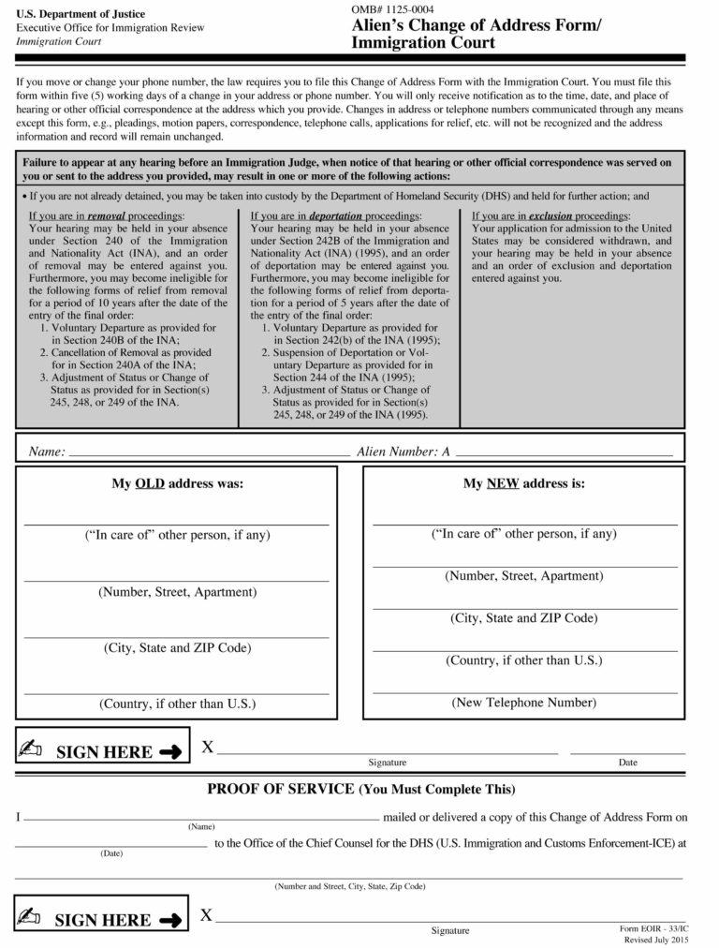
Johnny Smith
Pro Se
123 Main Street
Anywhere, NY 01987
P: (555) 554-1212
E: johnnysmith@whatmail.com

UNITED STATES DEPARTMENT OF JUSTICE
EXECUTIVE OFFICE FOR IMMIGRATION REVIEW
SAN ANTONIO IMMIGRATION COURT
____________________________________
In the Matter of: )
)
Smith, Johnny ) File No. 123456789
)
In Removal Proceedings )
____________________________________)

Immigration Judge: Johnson Master hearing date: December 30, 2027 at 1PM

RESPONDENTS’ WRITTEN PLEA

I, Johnny Smith (A#123456789), appearing Pro Se, make the following representations:

- I concede proper service of the Notice to Appear dated June 12, 2019;

- I understand:

  - The rights set forth in 8 C.F.R. § 1240.10(a);
  - The consequences of failing to appear in Court as set forth in INA § 240(b)(5);
  - The limitation on discretionary relief for failure to appear set forth in INA § 240(b)(7);
  - The consequences of knowingly filing or making a frivolous application as set forth in INA § 208(d)(6);
  - The requirement to notify the Court within five days of any change of address or telephone number, using Form EOIR-33/IC pursuant to 8 C.F.R. § 1003.15(d);

- I admit the following allegations on the Notice to Appear: 1 – 4;

- I concede removability from the United States;

- In the event of removal, I decline to designate a country of removal;

- If my relief from removal requires an application, I will file the application (other than asylum), no later than fifteen (15) days before the date of the individual calendar hearing, unless otherwise directed by the Court. I acknowledge that, if the application(s) are not timely filed, the application(s) will be deemed waived and abandoned under 8 C.F.R. § 1003.31(c). If I am filing a defensive asylum application, I will file it at the date the Immigration Judge specifies or earlier;

- If background and security investigations are required, I will request from DHS the biometrics instructions and will timely comply with the instructions. I understand the instructions. In addition, I understand that failure to provide biometrics or other biographical information within the time allowed will constitute abandonment of the application unless I demonstrate that such failure was the result of good cause.

- I am unable to estimate the time needed for an individual hearing.

- I speak English.

December 18, 2018 ______________________________
Johnny Smith
Respondent

RESPONDENT’S PLEADING DECLARATION

I, Johnny Smith, understand my rights in removal proceedings. I waive a further explanation of those rights by this Court.

I understand the consequences of failing to appear for a hearing. I understand the consequences of failing to appear for a scheduled date of departure or deportation.

I understand the consequences of knowingly filing a frivolous asylum application.

I understand the consequences of failing to follow the DHS biometrics instructions within the time allowed.

I understand that if my mailing address changes I must notify the court within 5 days of such change by completing an Alien’s Change of Address Form (Form EOIR-33/IC) and filing it with this Court.

Finally, I know what my written pleading says. I understand it, I agree with it, and I request that the Court accept it as my pleading.

December 18, 2019 ______________________________
Johnny Smith

Johnny Smith
Pro Se
123 Main Street
Anywhere, NY 01987
P: (555) 554-1212
E: johnnysmith@whatmail.com

UNITED STATES DEPARTMENT OF JUSTICE
EXECUTIVE OFFICE FOR IMMIGRATION REVIEW
SAN ANTONIO IMMIGRATION COURT
____________________________________
In the Matter of: )
)
Smith, Johnny ) File No. 123456789
)
In Removal Proceedings )
____________________________________)

Immigration Judge: Johnson Master hearing date: December 30, 2027 at 1PM

RESPONDENT’S MOTION TO CHANGE VENUE

I, Johnny Smith (A#123456789) hereby move this Immigration Court to allow venue to be changed from the San Antonio Immigration Court to the Anywhere Immigration Court pursuant to 8 C.F.R. § 1003.20 and Matter of Rahman, 20 I&N Dec. 480 (BIA 1992). In support of this motion, Respondent states the following:
- I am a citizen of Mexico and entered the United States on April 1, 1988;
- I have been in removal proceedings before the Immigration Court in Anywhere, NY since my immigration arrest in July of 2015 in San Antonio, Texas;
- At the time of my immigration arrest, I was visiting Texas only temporarily, and I have lived in Anywhere, NY at all times since entering the United States;
- I still live in Anywhere, NY, however I now live at a different address in Anywhere;
- The immigration benefits I am or will be filing for include cancellation of removal, asylum, adjustment of status, or voluntary departure;
- My permanent physical and mailing address is as it appears on his E-33 Change of Address Form, filed with this motion: 123 Main Street Anywhere, NY 01987;
- I have included a written pleading to the Notice to Appear;

WHEREFORE, I request that the Immigration Court change venue from San Antonio, Texas to Anywhere, New York, where the Immigration Court properly has jurisdiction over my removal proceedings.
Respectfully Submitted,
_____________________________
Johnny Smith
Respondent

EVIDENCE OF ADDRESS CHANGE GOES HERE

PAGES 7 - ????

Johnny Smith
Pro Se
123 Main Street
Anywhere, NY 01987
P: (555) 554-1212
E: johnnysmith@whatmail.com

UNITED STATES DEPARTMENT OF JUSTICE
EXECUTIVE OFFICE FOR IMMIGRATION REVIEW
SAN ANTONIO IMMIGRATION COURT
____________________________________
In the Matter of: )
)
Smith, Johnny ) File No. 123456789
)
In Removal Proceedings )
____________________________________)

Immigration Judge: Johnson Master hearing date: December 30, 2027 at 1PM

ORDER OF THE IMMIGRATION JUDGE

Upon consideration of the Respondent’s motions, it is HEREBY ORDERED that the motions be GRANTED DENIED because:
- DHS does not oppose the motion.
- The Respondent does not oppose the motion.
- A response to the motion has not been filed with the court.
- Good cause has been established for the motion.
- The court agrees with the reasons stated in the opposition to the motion.
- The motion is untimely per ___________________________.
- Other:
Date: ___________________ _____________________________
Slim T. Johnson
United States Immigration Judge

Certificate of Service
This document was served by: [ ] Mail [ ] Personal Service
To: [ ] Alien [ ] Alien c/o Custodial Officer [ ] Alien’s Atty/Rep [ ] DHS

Date: _____________________ By: Court Staff_______________________

Attachments: [ ] EOIR-33 [ ] EOIR-28 [ ] Legal Services List [ ] Other
PROOF OF SERVICE

Name of alien or aliens: Johnny Smith

A Number: 123456789

On date: December 18, 2018

I, Johnny Smith, served a copy of this document:

Respondent’s Written Plea and Motion to Continue

and any attached pages to:

<<ICE OFFICE WITH JURISDICTION OVER YOUR CASE>>

By: First class mail

Signed,

___________________________
Johnny Smith

